Use Case – ONAP Support for 5G Wireless Network

Name of Use Case:
5G Network Deployment, Slicing, Optimization and Automation

Use Case Authors:

Amdocs
AT&T
Ericsson
Intel
Viavi

History
Revision | Author | Comment
… |  | …based on “v4_noMarks”
8/16/2017 | Ericsson: John Quity, Peter Loborg, Oskar Malm | Suggestions for goal/pre-/post-conditions for use cases
Suggestion? Maintain a revision history list while working – prune or remove when done.

General Description:
The purpose of this document is to present a high-level use case for the deployment and optimized management of a 5G network while using the slicing concept for management of shared resources using ONAP. While the intent of the use case is to describe the overall 5G network, the initial focus will be on the RAN. The use case describes a Service Provider (SP) need to deploy a disaggregated 5G Radio Access Network (3GPP 5G Option 2-2 configuration). Some of the disaggregated network functions are expected to be virtualized, running on a cloud infrastructure and while others will be appliance based peripherals. ONAP should support the complete lifecycle management of this 5G Radio Access Network, using Service Design and Creation (SDC) for design and onboarding of the various models and artifacts for physical and virtual network functions, including creation of recipes/descriptors and policies for their initial deployment, and associated transport (WAN / LAN) connectivity. Further, to support the SP needs for lifecycle management of the shared resources, ONAP should support the data collection and analysis, policies and analytics to identify actionable conditions, and support automatic closed loop actions for the RAN deployment, optimization and slicing management.
Here are some of the network elements in 5G RAN:
- Distributed Radio Element
- Distributed BBU
- Centralized BBU and nrt-L2 function (CU-UP)
- Centralized Radio Control Unit (CU-CP)
The next sections describe the details of the RAN deployment, E2E slicing and optimization.
5G Disaggregated Radio Access Network Deployment
This use case is rather large, and will benefit from being divided into smaller parts.
The use case describes a process where the detailed description of available hardware and what vendor specific internal resources will result from that is described in a descriptor file provided by the vendor. The cell planning and what radio cells will use which of these vendor specific internal resources is created using a dedicated radio planning tool, resulting in configuration data to be used when deploying the VNFs and PNFs.

Goal: A planned list of 5G Nodes are on-boarded into ONAP, and ONAP configures the Nodes to the level they are ready to handle traffic. ONAP begins to actively monitor and manage the nodes.
Actors
- RAN Vendor – organization and person(s) responsible for delivering the RAN equipment and related licenses and descriptor data describing the intended configuration and usage of the equipment.
- RAN Integrator – person(s) responsible for onboarding new HW and SW and for defining new services (is this a too broad category of roles?)
- RAN NOC – person(s) monitoring the network daily, possibly also responsible for configuring and fine-tuning automation of various monitoring and alarm response activities.

Preconditions
To clarify the limits of this use case the following is asumed:
- Requirements on RAN coverage is well defined and documented (frequencies, power levels, coverage, and capacity)
- A planned realization of these requirements exists (planning of cell sites, equipment an and cell structure)
- The Core Network with its VNFs and transport network is operational and known to ONAP (is managed by the same ONAP instance or is known and reachable (can be addressed and connected to according to 3GPP defined methods)
- The infrastructure is prepared for the RAN deployment; Initial network and hardware planning and procurement is completed, resulting in
  - any new hardware needed has already been delivered and installed, both outside the data center (new PNFs and their cabling) and inside the data center
  - descriptions of the new hardware and basic transport to the data center external hardware have been on-boarded
- Radio Configuration Data, software products and license information has been provided by the RAN vendor and is now accessible to the RAN Integrator
- A single RAN Vendor delivers RAN equipment and functionality
- A single Telecom operator…
  - Owns or leases data center equipment, cell sites, physical transport, and any new equipment installed on these sites
  - Owns and operates the resulting RAN
(e.g., no slicing, RAN sharing or other cooperation requiring elaborate isolation between multiple parties)
  - Is the single user of the entire ONAP based management system
Postconditions
The 5G RAN is providing RAN service for the user equipment according to expectations:
- All planned services are on-line, providing FCAPS data through the relevant channels
- RAN NOC personnel have full access to the FCAPS data and ONAP automation framework
  - Dashboard or other NOC tools configured to display relevant RAN data
  - Calculation and monitoring of key performance indicators is activated, used to verify the capacity requirements
  - a first automation use-case reacting on an incident or state change have been implemented
Steps
The steps are sub use cases, some to be used repeatedly and other only once.
- Define the concepts needed to describe and work with the RAN, including…
  - Define model/attributes 5G VNF/PNF Resources
  - Define the ONAP view of the service entities to be provided by VNF/PNF resources
  - Design parameters needed for use by ONAP Optimization Framework (HAS) for placement of 5G VNF resources
  - Define the policies (e.g. including placement constraints) associated with each radio network function and its management
  - Design the configuration aspects for each of the emulated network elements (testing purposes) based on the services that need to be supported and sample Radio Configuration Data
  - Testing of these concepts in an emulated environment
- Onboarding of RAN functionality and initial trial rollout (limited area):
  - Design the configuration aspects for each of the network elements based on the services that need to be supported and the Radio Configuration Data and license information provided by the vendor
  - Design parameterized Recipes/models for instantiating various disaggregated Radio Access Network elements and associated network connectivity (front haul and backhaul).

  - Design recipes for Data Collection, Analytics, service level metrics, and associated corrective actions when defined levels are breached for each network RAN element and the RAN network
  - Policy definition and Policy enforcement points (NF, Controllers, DCAE / SO, etc.) taking corrective actions when anomalous condition is detected
  - Instantiate a selected few services and related VNFs and PNFs:
    - At least one service that will require new instantiation of both a PNF and a VNF
    - At least one service that re-uses and existing PNF or VNF
  - Verify that service is provided and can be monitored through dash boards and NB App API using basic observability data and calculated KPIs.
  - Verify that policy definitions and their corrective actions are active and has intended effect.
- Full rollout of remaining parts of RAN:
  - Re-using the descriptors and the recipes developed in step 1 and 2 to instantiate the remaining services.
  - Verify that service is provided and can be monitored through dash boards and NB App API using basic observability data and calculated KPIs.
Open issues
- What is a unit of a RAN service? For a 4G RAN the EUtranCell can be a suitable service, or for RAN sharing situations, even a prioritized portion of a cell and its capacity.
- How to model/describe a mapping between a generic service model for the RAN and a vendor specific implementation, allowing the ONAP user to operate seamlessly over the borders of a multi-vendor system?

Old text: (to be part of the realization description?)
The ONAP execution environment must support the following flow:
- On receiving a request for 5G Radio Access Network instantiation, decompose the request into individual resource requirements
- Orchestrate each resource, instantiate virtual resources into the cloud using Multi-VIM interfaces
- Establish necessary local area and wide area network connectivity (LAN & WAN).
- Start fault, performance, and log data collection as described during the design time.
- Track inventory/topology of slices and their states with AAI
- Compute analytics, as necessary, to monitor the environment and publish anomalous conditions
- Trigger corrective / remedial action for network impairments and for violations of service levels
- Closed loop actions initiated using the SO and / or controllers
5G Network slicing
Each Service Provider (SP) needs to support a rich set of advanced 5G wireless services, such as enhanced Mobile Broad Band (eMBB), massive Internet of Things (mIoT), and Ultra-Reliable, Low-latency Communications (URLLC ), for mission critical communications.
These services have very different requirements on latency, reliability, availability, mobility, and bandwidth. Deploying multiple separate networks to support these varying requirements is not practical. End to End vertical network slicing as defined by 3GPP provides specifications for efficient creation of multiple logical networks sharing a common network infrastructure while meeting the specified service levels for each of the services. ONAP must support the complete lifecycle management of such network slicing.
Automated Configuration: Automated configuration of a slice during the instantiation, configuration, and activation phases, a newly created set of identifying parameters automatically configured
Automated reconfiguration. Automated reconfiguration happens during run-time e.g. an active slice can be reconfigured automatically because of a change in the service requirements or service conditions.
Here are some of the network elements participating in E2E Slicing:
- Distributed Radio Element
- Distributed BBU
- Centralized BBU and nrt-L2 function (CU-UP)
- Centralized Radio Control Unit (CU-CP)
- Layer 3 Transport Elements
- NG S/P Gateway
- NG PCRF
- Etc.
In order to enable both an e2e service view and re-usable services from the different segments/domains in the network, the design must done in such a way as to support:
- Abstraction of the services offered by the different domains/segments
- Ability to tie the services offered by the different domains/segments into an e2e service.
- Support the network to provide isolation between the slices (to the extent that is reasonable according to the networks capabilities).

Goal: A request from the order handling system is received by ONAP. ONAP instantiates the slice without any manual operator interaction. ONAP start actively monitoring the slice.
Use Case 1: Design slice template
Use Case 2: Instantiate slice automatic trigger by request from BSS system
Use Case 3: Manage the slice SLA/SLO

The ONAP Design Studio (SDC) must support the following capabilities
- Define model/attributes for slice and its relationship to underlying VNF/Resources
- Design parameters needed for use by ONAP Optimization Framework (HAS) for decomposition and placement of resources needed for the slice
- Design recipes/models for instantiating slices, modifying / expanding / shrinking slices, etc.
- Design recipes/models for instantiating dedicated resources (e.g. AR / VR server)
- Create an abstracted view of the services provided by the RAN, Transport, Core network functions, and create configuration parameters for these
- Author policy definitions and their enforcement points (VNF, Controllers, DCAE / SO, etc.)
- Specify fault, performance and log data collection, Analytics, thresholds for violations, and associated corrective action
The ONAP execution framework should support the following activities.
- The Orchestrator executes the E2E Slice creation / modification recipe
- Instantiate any new VNF needed for the slice
- Pass configuration specifications, as per abstraction standards, to the RAN controller for radio slice creation, and packet core for core slice creation
- Pass QoS, bandwidth, resiliency requirements for transport network to SDN-Controller
- Configure the vEPC using App-C, orchestrated by EPC resource and service orchestration
- Start data collection and service monitoring at the relevant DCAE locations
- Track inventory/topology of slices and their states with AAI
- Collect data and perform the needed analytics about the various slices
- Trigger corrective / remedial actions for detected network impairments and service level violations
- Closed loop action initiated using SO and / or controllers
Note: ONAP also needs to be able to instantiate the required ONAP components to support the slice.
- <<<<<< Lets work on a figure to put here to help the understanding. This would be good to describe RAN scope vs E2E scope (and EPC scope, etc.). >>>>>>

Post-Condition: The Network slice instance is operational. ONAP is actively collecting measurement information for the slice. All related Policies are deployed and active across the ONAP components.
Network Slice Optimization:
A Service Provider (SP) needs to automate 5G network Optimization for support of real time (wireless services), including dynamic slicing management. To effectively manage a slice and services running on it, we need to monitor each slice segment, monitor E2E slicing KPI and Service KPI. A slice can be modified automatically to avoid degradation of services in case of network function overload, dynamic topology change, etc. The status of the target slice is monitored, including the status of network functions and services. Examples of parameters to be monitored on the network functions and for the services are throughput, latency, the number of connections, etc. Based on pre-configured targets and/or policies, the management system may automatically configure some slice-specific parameters for the slices to get a better performance from the services provided. For example, based on optimizations & analytics (e.g. SON), which are driven by network / services performance data, the management system may re-configure the links between some network functions to modify the topology of the slice for improvement in resource utilization and/or in the QoE of services supported by the elements.
Automated Healing. For the running slices, SON algorithms could identify the failures and apply some corrective actions. The network functions which compose the slice support fast failure recovery and healing mechanisms, thus enabling automatic convergence of the affected network functions to a stable desired state. The results of the self-healing needs to be notified to the operator. ONAP must provide the following functionality for full lifecycle management of Self Optimizing 5G network & Slices (SON)
This needs to be done following the below principles:
- Support for optimization and healing within each domain/segment.
- Separation of concerns and abstraction between the domains/segments.
- Support for e2e service optimization and healing.

Goal: A network slice instance experiencing an anomaly/SLA breach condition, is detected immediately (later use case :- predicted just before?) by ONAP, ONAP automatically takes corrective action, re-configuring a part of slice/and or underlying network. ONAP verifies the action has remediated the issue.
Pre-Condition: The Network slice is operational, ONAP is actively collecting measurement information for the slice
Post-Condition: The Network slice is operating within SLA/SLO
Radio Access Network Optimization:
A Service Provider (SP) must, in real-time, optimize the performance of the 5G Radio Access Network (RAN). This optimization may be effected via dynamic configuration of relevant 5G radio and backhaul network parameters. Such optimization is part of the so-called “Self-Organized Networking” or SON. ONAP will enable the design and implementation of an open SON ecosystem for 5G RAN optimization by providing a common open framework that (a) enables multiple SON vendors to implement their SON solutions on the same network and (b) provides facilities for managing and coordinating the concurrent application of multiple independently developed and deployed SON algorithms, avoiding or resolving conflicts that might arise.
In this respect, example SON use cases that could be designed and implemented on ONAP include the following:
- 5G White space/unlicensed spectrum management, where SON allocates bandwidth resources to users based on their traffic and mobility profiles, as well the availability of licensed bands in a given geographical location.
- New techniques for 5G energy optimization: where a SON algorithm dynamically adapts the transmission power and/or tilt of 5G cells based on traffic conditions, in order to maximize the power efficiency of the network. This is especially important in dense networks
- New techniques for load balancing: where the allocation of user traffic to 4G and 5G cells in the region is based on a wide set of inputs including user load, traffic requirements/conditions, and environmental factors.
The application of ONAP-based SON solutions will need to be managed and coordinated appropriately. SON coordination is necessary in order to ensure that independently executing SON functions do not conflict, or otherwise negatively interact with one another. The SON coordination should be policy-driven, allowing operators to easily tailor the logic governing SON function interactions to their own unique network scenarios and business objectives. Finally, such coordination should also take into account 5G-specific mechanisms such as network slicing and be able to interoperate with legacy proprietary SON platforms to the extent possible.

Goal: A Radio Area experiencing an anomaly/SLA breach condition, is detected immediately (later use case :- predicted just before?) by ONAP, ONAP automatically takes corrective action, re-configuring the Radio service area/ and or supporting transport/core. ONAP verifies the action has remediated the issue.
Pre-Condition: The Radio Network is operational, ONAP is actively collecting measurement information for the slice
Post-Condition: The Radio Service Area is operating within SLA/SLO

In order to support the optimization capabilities described (both the Slicing and RAN optimizations), ONAP must support design and execution capabilities described below.

The ONAP Design Studio (SDC) must support the following Capabilities:
- Design per slice segment Data Collection, Analytics, SLA / SLO calculations
- Design E2E Slice & Services Analytics and SLA / SLO calculation
- Define policies / anomalies that indicate sub-optimal slice segment / E2E slice, and service performance
- Define policy evaluation to identify best possible slice / slice segment and service optimization action(s)
- Create recipes for addressing slice performance degradation
- Design data collection and analytics for various network optimization functions
- Define policies / anomalies that indicate sub-optimal network performance
- Define policy evaluation to identify the best possible optimization action(s)
- Define SON coordination policies for the prevention, detection and resolution of conflicts or negative interactions of individual SON functions
- Create recipes for executing network optimization steps (e.g. new configurations for RAN elements)

ONAP execution framework should support the following activities:
- Start data collection in various DCAE instances and accessing historical data when needed
- Perform needed SON analytics and generate an event when network impairments or service level violations are detected (e.g. when network optimization action is needed)
- Trigger policy evaluation to identify the best solution to optimize network performance
- Coordinate SON functions via policy evaluation to ensure that independently executing SON functions do not conflict or negatively interact with each other
- Initiate radio access network change using SO and / or controllers

Users and Benefits:
This ONAP use case enables automated lifecycle management of large scale disaggregated 5G radio access networks and E2E network slices. It also enables the deployment and life cycle management of hybrid 5G networks (a combination of PNFs and VNFs)
Acronyms/Glossary
SP | Service Provider
SDC | ONAP Service Design & Creation
DCAE | ONAP Data Collection, Analytics & Events
SO | Service Orchestrator
Multi-VIM interface | ONAP interface agnostic to the Virtual Infrastructure Manager used
eMBB | Enhanced Mobile Broadband
mIoT | Massive Internet Of Things
URLLC | Ultra-reliable low latency communication
SON | Self-Organizing Network

VNF:
Radio Access Network Topology:

Virtualized Radio Control Function (CU-CP)

Virtualized BBU-CU & UP L2nrt components
Distributed BBU-DU, L1+L2rt Function (UP+CP)
Distributed Radio Unit (UP+CP)

E2E Slicing Network Topology:

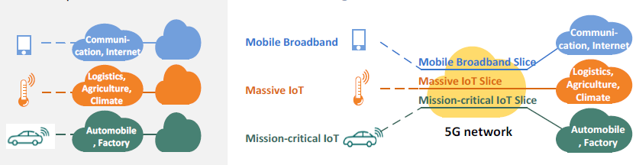

Work Flows:
ONAP Architecture for RAN Management:
Note: The ONAP architecture diagram below will be aligned with the ONAP architecture diagram for R2, when available.
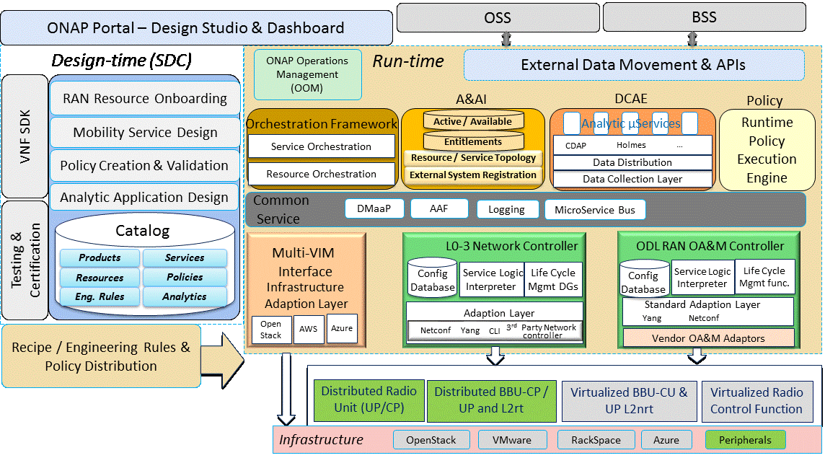Project Impact:
This is a significantly broad use case and will impact all major modules of ONAP. List of enhancements in each module will have to be identified over the next several weeks.

Work Commitment:
AT&T may provide development resources but would like to collaborate with other ONAP members to fully realize this use case.

